Andrew Daly
03/09/2021
BIT 480 (001)
Metabolic Engineering of S. cerevisiae to Observe Impacts on Beta-Carotene Production
Conceptual Background
Chances are, you’re already familiar with yeast as the powder that you throw into your bread mix that allows it to rise. But yeast comes in various forms and strains, and not all of them are suitable to be standard baker’s yeast. These eukaryotic single-celled organisms reproduce quickly by budding or mating, grow easily at ambient temperatures, and require very little upkeep beyond refreshing the colonies with a basic growth medium. However, they can be modified to do more than convert simple sugars into carbon dioxide. With a little bit of genetic tinkering, yeasts have been engineered to produce compounds such as ethanol, proteinases, peptides, insulin, vitamins, and much more. The main method through which these modern feats are accomplished is known as metabolic engineering.
More precisely, metabolic engineering involves manipulating an organism in such a way to produce useful products or product derivatives. Most metabolic engineering on yeasts like Saccharomyces cerevisiae takes place through genetic manipulation, where either the genes of the wild-type are modified or genes from other species are implanted into the yeast. Think of resource production in these yeasts as a small factory where each gene represents a piece of equipment. Maybe one existing piece can be tinkered to increase efficiency, eliminated to reduce a material bottleneck, or a new machine can be brought in to change the process dramatically.
Thankfully, many metabolically engineered yeasts are modified to produce these substances without harming the producers themselves, so as not to kill the goose laying the golden eggs. Thankfully, examining the mechanisms involved in creating these products does not involve beheading any magical waterfowl. If a scientist comes across a strain of yeast such as S. cerevisiae that exhibits her desired qualities, a simple genetic screen can be used to analyze the manipulated gene(s). If this was sourced from a pooled deletion library, she can scan a certain “barcode region” and, using the adjacent set of base pairs, find which gene was deleted. From this, she can examine the phenotype of the yeast and learn whether the deleted gene upregulated, downregulated, or had no effect on the pathway of interest.
Beta-carotene is one such material that can be produced in S. cerevisiae through metabolic engineering. While not naturally produced in this strain, it can be created through a process called the mevalonate pathway if several other genes from different species are incorporated into the subject. These genes provide the correct materials to transform the naturally-produced mevalonate into a beta-carotene precursor and provide the yeast cell with a nice, sharp hue of orange. Apart from enhancing the yeast’s appearance, beta-carotene can also be useful to humans due to its ability to serve as a vitamin A precursor, food coloring agent, and dampener of ultraviolent sensitivity. This could come to great use in both industry and food supplements for the malnourished with minimal amounts of attention needed, beyond initial plating and occasional resupply of colony sugars, to harvest this product.

Class Activities
Thankfully, because beta-carotene is the only known controller for the orange color seen in S. cerevisiae, it was hypothesized that any change in this hue would be correlated to some interference in beta-carotene production, likely through the mevalonate pathway. To this end, two S. cerevisiae colonies that had each been transformed with a sample from the pooled deletion library were selected and genotypically analyzed to see if the genes deleted played any role in beta-carotene production based on apparent phenotype.
However, the class did not simply start with us picking premade colonies and looking at a genetic barcode. S. cerevisiae does not naturally produce beta-carotene, and so was first required to be transformed with genes allowing for this. Genes crtYB, crtI, crtE, and tHMG1 are the genes necessary in beta-carotene production, though only the first three were needed to be transformed into the sample because tHMG1 is native in S. cerevisiae.
In order to transform these genes into the yeast, we used a method known as Yeast Golden Gate, or yGG, assembly. This method combines the coding sequence of interest, otherwise known as a CDS, between a promoter and terminator sequence before combining these all into what is known as a transcription unit, or TU. Each of these segments originated from a separate plasmid and are recombined into an acceptor vector which inherently codes for a red-fluorescing protein, though this segment of DNA will be replaced by the TU. This serves as an efficient way to screen whether or not the cells have been successfully transformed, since the original TU’s plasmids also held a gene conferring resistance to a different kind of antibiotic compared to the acceptor vector.
Assembly via yGG was the most convenient option for this lab because of its “scarless” ligation. The type IIS restriction enzymes used to cut out each segment leaves nondestructive recognition sites at each spot, allowing ease of access for both digestion of the acceptor vector and ligation of the TU’s. This is why the process, when partnered with a system known as VeGAS, is often referred to as “one-pot ligation and digestion.”
Once each TU was assembled into the proper acceptor vector and successful translation and expression for each was verified in colonies of E. coli, they had to be implemented into S. cerevisiae. This was achieved through a method known as the yeast Versatile Genetic Assembly System, or VeGAS. This system involves capping each end of the transcription units created through yGG, as well as the open ends of the new acceptor vector, with specific VeGAS adapters. These adapters are specific towards themselves, regardless of direction.
The TU’s necessary for beta-carotene production were then combined with the TU assembled through yGG conferring kanamycin resistance and amplified via PCR before being transformed into the awaiting yeast cells from the pooled deletion library. However, this KanMX resistance CDS was previously amplified alongside UPTAG and DOWNTAG sequences that would then be able to locate the barcode regions of the pooled deletion library specimen that made up this yeast colony. Colonies were heated for a short time to assist in allowing the plasmid into the nucleus. S. cerevisiae was then able to use a process known as homologous recombination to assemble the VeGAS adapters together itself, resulting in a yeast cell with kanamycin resistance and the ability to produce beta-carotene. The sample was then allowed to grow further and produce more colonies before later examination.

Results
Once the samples had all been transformed and allowed time to grow, they were phenotypically compared to wild-type samples and subsequently chosen for genotypic analysis. The chosen colonies of this study consisted of pooled deletion colonies numbers 5 and 6. While colony 5 strongly resembles that of the control, colony 6 appears to have a less orange and more yellowed tint, as can be seen below.
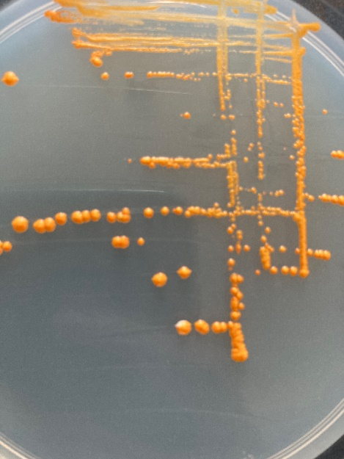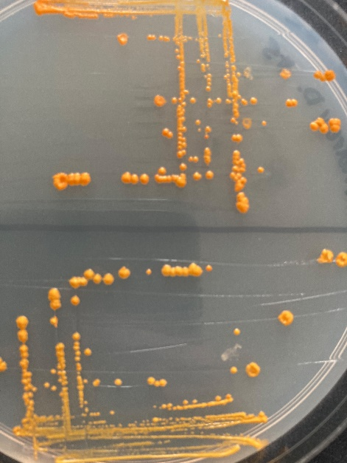
C
B
A
Figure 1: (A) Wild-Type S. cerevisiae BY4741 Transformed with Transcription Units and Vector. (B) S. cerevisiae Pooled Deletion Colony #5. (C) S. cerevisiae Pooled Deletion Colony #6.
The barcode regions of each colony were screened soon after using SnapGene software and compared against the pooled deletion library manufacturer’s list of the trailing base pairs for both the UPTAG and DOWNTAG regions. This revealed that colony 5 had deleted the gene VTC3 and colony 6 had deleted the gene DAL3. Both of these genes and their role in the native S. cerevisiae system and non-native beta-carotene production pathway were examined through the Saccharomyces Genome Database, or YGD.
VTC3 is not a major regulatory gene itself, but rather is a part of a larger vacuolar transporter chaperone, or VTC, complex. This complex is responsible for doing what the name implies – transporting a variety of materials throughout the vacuole, more specifically regulating the accumulation of polyphosphates. While this has no obvious role in any metabolic pathway, and based on appearance no effect on beta-carotene production, its ability to shuttle polyphosphates would likely include beta-carotene intermediates such as GPP or FPP. However, similar coloration between wild-type and colony 5 samples lead to the belief that any role VTC3 may have played in shuttling the main VTC complex was supplemented by the other VTC genes, substituted entirely, or possibly even negligible in the first place. In this case, it seems safe to say that VTC3 is a non-regulator for beta-carotene production.
DAL3, on the other hand, bears a closer resemblance to playing a role in beta-carotene production. This gene codes for an enzyme which converts an intermediate of the allantoin degradation pathway into urea and glyoxylate. The only oddity comes into play when comparing the mevalonate and allantoin pathways, as neither shares a single common chemical besides hydrogen ions. Given the amount of hydrogen ions and materials such as NADPH in normal cellular reactions responsible for maintaining homeostasis, it seems highly unlikely that the addition of a single hydrogen ion into the cell for each would-be allantoin degradation would noticeably decrease beta-carotene production. However, the phenotype seems to reveal that removing DAL3 has done so, despite the lack of any published material establishing such a connection. Based on experimental findings, however, DAL3 may be considered a positive regulator of beta-carotene.
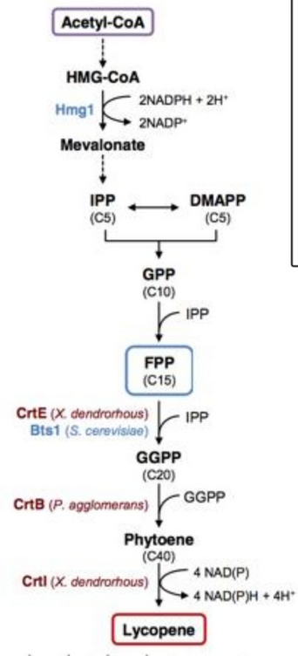
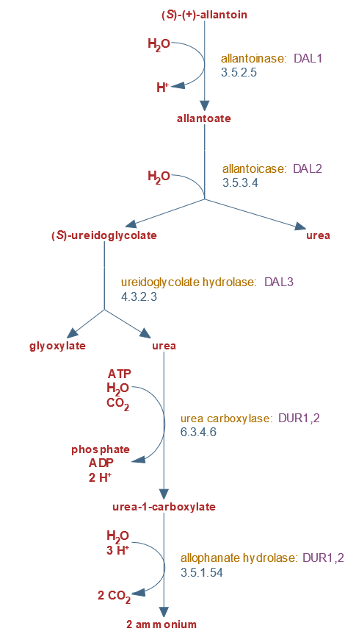
B
A

Figure 2: (A) Allantoin Degradation Pathway. (B) Mevalonate Degradation Pathway. Lycopene is a basic precursor to beta-carotene.

Continued Process
If there were two things that this class has taught me, it would be that yeast is a magnificent organism, and that I need to get to the bottom of what the metabolic relation between DAL3 and beta-carotene is. While the pathways may not share too many direct connections, I would be interested in examining other metabolic pathways necessary for survival of the yeast cell and examining what the removal of one or more compounds might play in producing more or less of a target substance. Even beyond beta-carotene, examining the effect each gene deletion had on observable traits such as growth rate, thermotolerance, alkalinity, and other factors would be interesting to look into.

Conclusion
Though this experiment failed to definitively yield an answer as to why DAL3 seemed to be a positive regulator of beta-carotene in S. cerevisiae, it has enabled me to learn a wide variety of information concerning metabolic engineering and the importance of yeast in the industrial world. I will now be burdened with the need to observe every rising loaf of dough and wonder which strain of yeast went into its production, and whether or not it has anything to do with the hue of the resultant bread.

